Instructions for “One_VAT_App- LAPP”

**Please read and follow all the instructions for a proper use of the application!**

## Pre-requisites:

The template needs to be opened and saved with the .xlsx extension. It initially has the xlsb format. The transformation is done through the following steps:

* Open the Excel file with the initial template.
* Click on the "File" tab, followed by "Save As."
* Choose the .xlsx extension.

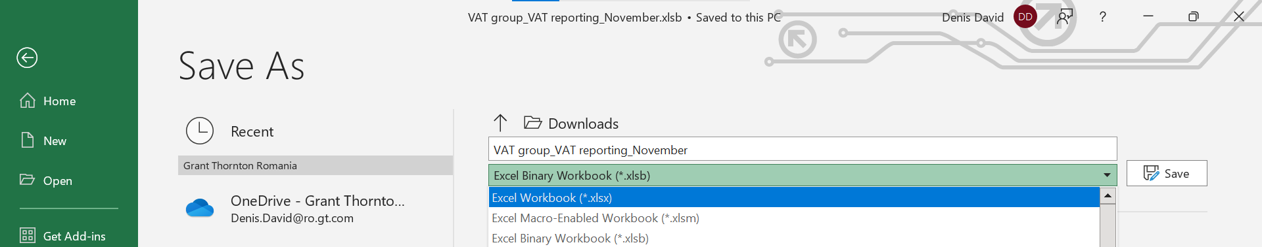

***IMPORTANT!!!*** For the XML related to each entity to be generated, the initial spreadsheets (even if not reviewed) should be first opened and saved before uploading them for XML generation, for each of the Group’s entities.

## Instructions:

1. Access the server at [Tax (vatappmirus.azurewebsites.net)](https://vatappmirus.azurewebsites.net/) and select “VAT Apps – Group” webapp from portal:



1. In the next page shown below, please enter the details and insert the file presented above (Journals and Company Info):

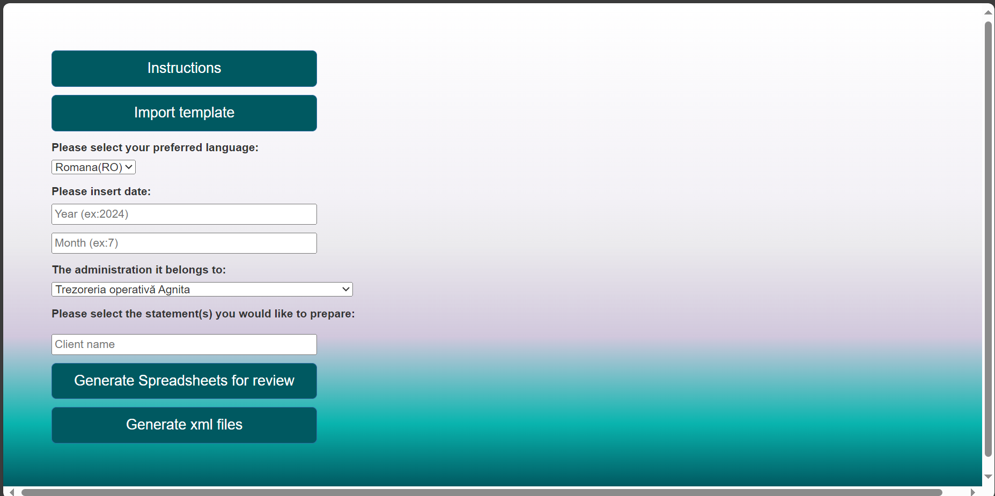

1. Enter the client’s name, select the language, select the administration.
2. Click “Import template” and import the template with D300 Sheet.
3. Click “Generate Spreadsheets for review”. Once clicking that, the robot will save the spreadsheet in the download folder.
4. App will generate an Excel Spreadsheet document named “One VAT app spreadsheets” + the name of the client.
5. Please review the Excel Spreadsheet named “One VAT app spreadsheets” and save it. Note that every change in the file will be transposed into the statements (XML file).
6. Press the button “Generate xml files” and will open the below page:

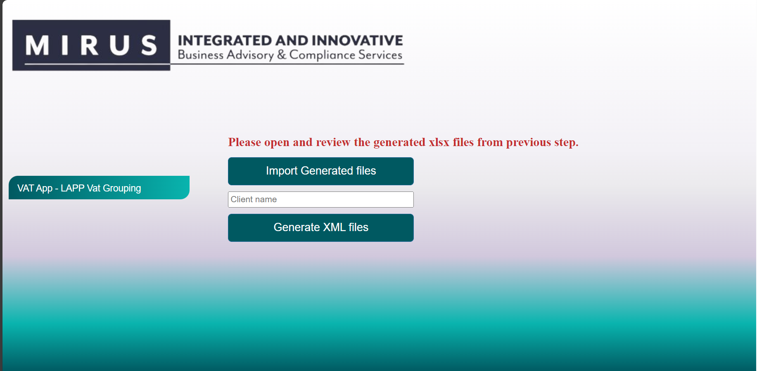

1. In the button “Import Generated file“, insert the reviewed Excel spreadsheet obtained on the step 7 and press the button “Generate XML file” to download the statements.
2. App will send a zip file “arhiva VAT apps” which contains the statement in XML format.
3. Please validate the xml file for D300 in DUKintegrator.

**For any issues, questions and/or suggestions, please contact:**

**Bogdan Constantinescu,** [**bogdan.constantinescu@ro.gt.com**](mailto:bogdan.constantinescu@ro.gt.com)

**David Denis,** [**denis.david@ro.gt.com**](mailto:denis.david@ro.gt.com)